- \Operation\Carton ejection\Carton ejection
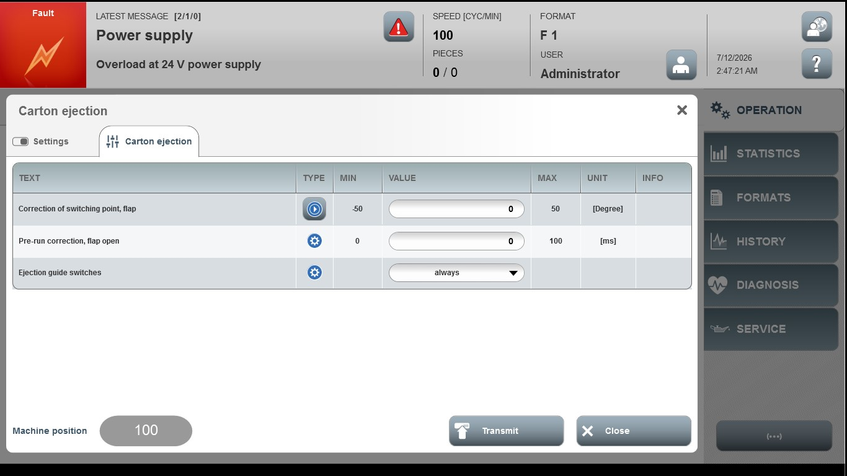

Acceptance criterion | Limits | Pass / Fail: Dev-No. | Date | Initials
Screen matches screenshot | N / A
Correction of switching point, top flap | -50 … 50
Pre-run correction, flap open | 0 … 100

